Halloween Trail 2022
Happy Halloween little Ghosts and Ghouls, now you are here you must follow the rules!
Keep your eyes peeled and look all around as we have hidden some spooky pictures waiting to be found!
Find them all, tick them off, then head to the shop to grab sweeties you can scoff!
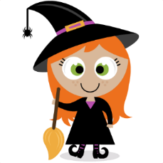  Location: The Bell  Joke: How do you make a skeleton laugh? |  | 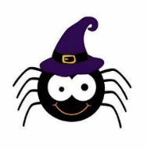  Location: Chapel Road  Joke: Why are ghosts bad liars?
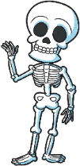  Location: Chesnut Road/Aveue Road  Joke: What do birds say at Halloween? |  | Location: Foregate Street  Joke: Why did the skeleton not go to the ball?
Location: Doebank Drive  Joke: What’s the worlds most famous skeleton detective? |  | 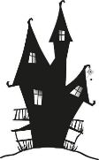  Location: Butler Street  Joke: What rooms do the ghosts avoid?
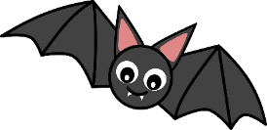  Location: Badger Brook Lane  Joke: Where does Dracula keep his money? |  | 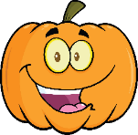  Location: Feckenham Road  Joke: What’s a witches favourite lesson in school
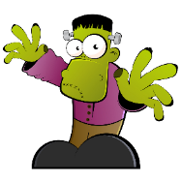  Location: Avenue Road  Joke: How do you know a vampire is poorly |  | 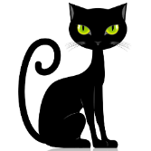  Location: Premier Shop  Joke: What do you call a witch that lives at the sea?

